### **Modbus Communication System with ESP32**

#### **Overview**

Develop a system that can send and receive Modbus requests and display the data on a web-based dashboard. The system uses an ESP32 microcontroller and can operate in two modes: master and slave.

#### 

#### **Components**

* **ESP32**: The microcontroller responsible for Modbus communication and hosting the web server.
* **ESAM E2002**: Electrical component that communicates with the ESP32 in master mode.
* **ModScan Software**: Software that communicates with the ESP32 in slave mode.

#### 

#### **Modes of Operation**

1. **Master Mode**
   * The ESP32 sends Modbus requests to the ESAM E2002.
   * It receives data from the holding registers
   * It correctly converts the data (eg. from 2 words of 16bit to a float)
   * It stores them in a local data structure
2. **Slave Mode**
   * The ESP32 receives Modbus requests from ModScan software.
   * It correctly converts back the data (eg. from a float to a 16bit word)
   * It responds with data from the holding registers.

#### 

#### **Initial Configuration**

1. **WiFi Setup**
   * The ESP32 starts in configuration mode with the SSID "CONFIGURE ME".
   * Connect to the "CONFIGURE ME" WiFi network.
   * A captive portal opens for configuring the ESP32 to connect to a new network (e.g., "NEW WIFI").
   * Once connected to "NEW WIFI", the ESP32 communicates its new IP address.
2. **Web Interface**
   * **Configuration Page**: Accessible via the new IP address.
     + Displays a table of all measurements in the holding registers.
     + Allows users to create, edit, and delete measurements.
     + For each measurement, users can define:
       - Register address range (eg. “124-125”)
       - Type (eg. “float”)
       - Read/write (eg. “read only”)
       - Label (eg. “V1”)
       - Description (eg. “Voltage Phase 1”)
       - Unit (eg “V”)  
         refer to the [E2002 Manual](https://esam.biz/wp-content/uploads/2020/05/E2002Man.pdf) pages 13-16 for more
     + Allows users to switch the ESP32 between master and slave modes.
     + Configure swap settings.
   * **Analytics Page**: Accessible via the new IP address.
     + Displays selected real-time data in a textual format.
     + Includes a user-friendly GUI for better visualization (Bonus)

#### 

#### **Evaluation Criteria**

| **Criteria Name** | **Criteria Description** | **Max score** |
| --- | --- | --- |
| **ESP32 - Modbus Master - Data Reception** | The ESP32's ability to send Modbus requests to the ESAM E2002 and accurately receive various data types, converting them correctly from holding registers. | 4 |
| **ESP32 - Modbus Master - Local Data Storage** | The ESP32's capability to save different data types from holding registers into local storage efficiently. | 1 |
| **ESP32 - Modbus Slave** | The ESP32's proficiency in responding to Modbus requests from ModScan software with accurate and reconverted data from holding registers. | 4 |
| **WiFi Configuration** | The ease and success of the initial WiFi setup via a captive portal, including the transition to a new network. | 4 |
| **IP Address Communication** | Accurate communication of the new IP address to the user after connecting to the new WiFi network. | 1 |
| **Configuration Page** | The completeness and usability of the configuration page, including the ability to create, edit, and delete measurements. | 3 |
| **Analytics Page** | The accuracy and clarity of real-time data display on the analytics page in textual format. | 2 |
| **System Stability** | The stability and reliability of the system during normal operation, including error handling and recovery processes. | 2 |
| **Documentation Quality and Completeness** | The quality and thoroughness of the documentation, providing step-by-step instructions, images, and relevant information for users to replicate or understand the product. | 3 |
| **Presentation Quality and Completeness** | The quality of the presentation, including well-structured content, clear visuals, and comprehensive coverage of all relevant aspects of the product such as functionality and architecture. | 2 |
| **Demo Quality** | The effectiveness of the product demonstration in showcasing its features, capabilities, and value proposition, being engaging, well-prepared, and leaving a positive impression on the audience. | 3 |
| **User Interface Design - BONUS** | The overall design and user experience of the web interface, including both the configuration and analytics pages. | 3 |
| **TOTAL** | | **32** |

#### **Evaluation Score Sheet**

Available to the person who will score the project and for autonomous self-evaluation.

| **Questions** | **Score** |
| --- | --- |
| **ESP32 - Modbus Master - Data Reception** | Max 4 |
| Does the ESP32 successfully send Modbus requests to the ESAM E2002? | 2 |
| Does the ESP32 correctly receive various data types from holding registers? | 1 |
| Does the ESP32 correctly convert various data types from holding registers? | 1 |
| **ESP32 - Modbus Master - Local Data Storage** | Max 1 |
| Does the ESP32 save received data correctly in local storage? | 1 |
| **ESP32 - Modbus Slave** | Max 4 |
| Does the ESP32 accurately respond to Modbus requests from ModScan? | 2 |
| Is the data reconverted correctly when responding to requests? | 2 |
| **WiFi Configuration** | Max 4 |
| Is the initial WiFi setup via the captive portal easy and successful? | 2 |
| Does the ESP32 correctly switch to the new network? | 2 |
| **IP Address Communication** | Max 1 |
| Does the ESP32 communicate the new IP address correctly after connecting to the new network? | 1 |
| **Configuration Page** | Max 3 |
| Are all necessary measurement details (address range, type, label, etc.) available for configuration? | 2 |
| Can the user add/edit/delete new measurements | 1 |
| **Analytics Page** | Max 2 |
| Is the real-time data received and displayed? | 1 |
| Is the data presented clearly in a textual format? | 1 |
| **System Stability** | Max 2 |
| Does the system operate stably under normal conditions? | 1 |
| Is error handling and recovery implemented effectively? (eg. modbus communication error) | 1 |
| **Documentation Quality and Completeness** | Max 3 |
| Is the documentation detailed and well-structured? | 1 |
| Does the documentation include step-by-step instructions? | 1 |
| Are images and relevant information provided to guide users? | 1 |
| **Presentation Quality and Completeness** | Max 2 |
| Is the presentation well-structured and visually clear? | 1 |
| Does the presentation comprehensively cover the product’s functionality and architecture? | 1 |
| **Demo Quality** | Max 3 |
| Is the product demonstration engaging and well-prepared? | 1 |
| Does the demo effectively showcase the product’s features and capabilities? | 1 |
| Does the demo leave a positive impression on the audience? | 1 |
| **User Interface Design - BONUS** | Max 3 |
| Is the web interface well-designed and user-friendly? | 1 |
| Does the configuration page have a good user experience? | 1 |
| Does the analytics page have a good user experience? | 1 |

#### **Frequently Asked Questions**

* When ESP is in slave mode, and I'm using MODSCAN, should the data I'm collecting be in real time? Yes, retrieved from the E2002
* Why do we need a configuration table? this enables the system to be flexible without changing the actual code if a modbus-compatible device replaces the E2002
* What should be the graphical representation of the system? I'm not interested in this, I'm more interested in the logic. To be flexible, a user should be able to view, add, edit, delete the information. How this is actually implemented visually is not really interesting.
* Why are you asking us to do this project? I'm expecting you to autonomously make the links with real life examples but this is already a real life example. In any IoT device nowadays there is a connection part (generally setup), a configuration part and a cloud part. I'm sure that if you practice on the first two, doing the third will be quite trivial.
* Can I develop part of the software outside the ESP and have the ESP just to be the server sharing the data? Yes but not required. I asked to do everything inside the EPS for ease of testing but I understand you would like to "separate the concerns" so you can do it in any way.

Presentazione:

Alessio: panoramica generale:

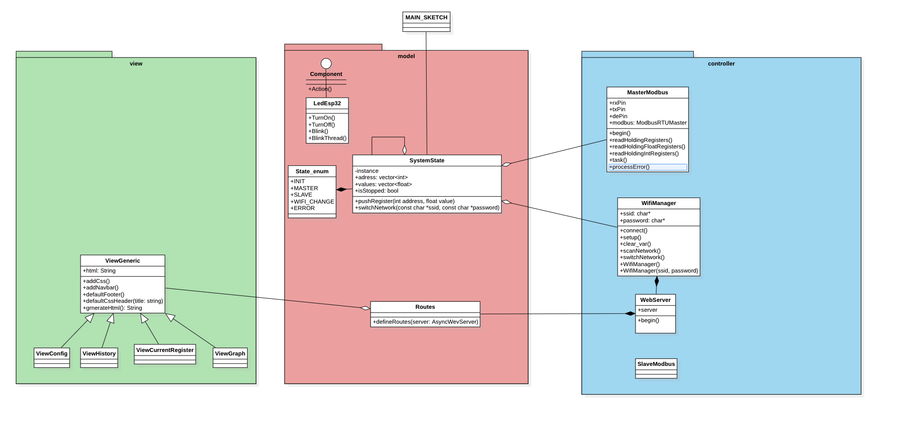

Enrico:

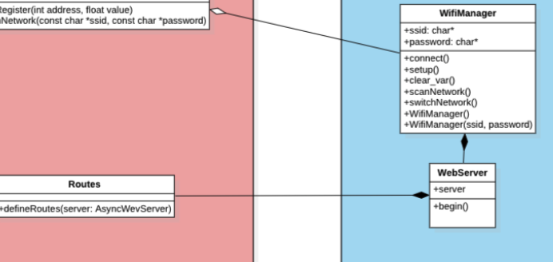

Simone

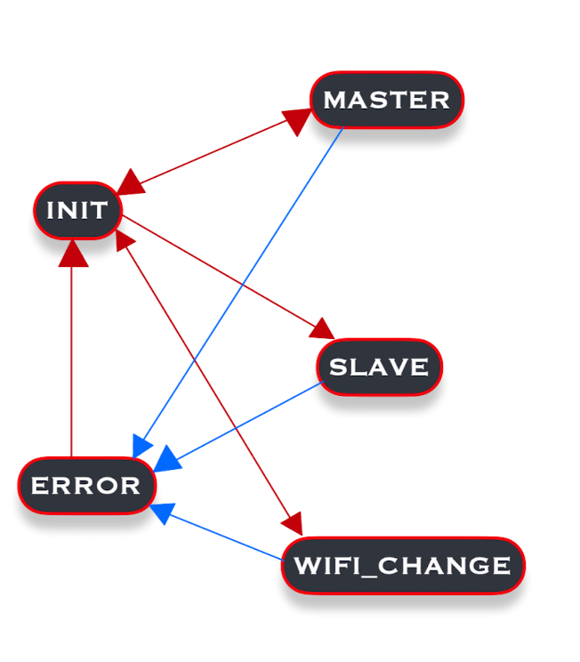

Il nostro sistema e pensato per funzionare esattamente come una macchina a stati..

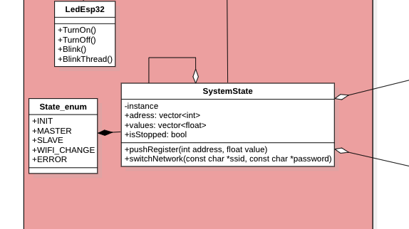

System State segue pattern singleton.